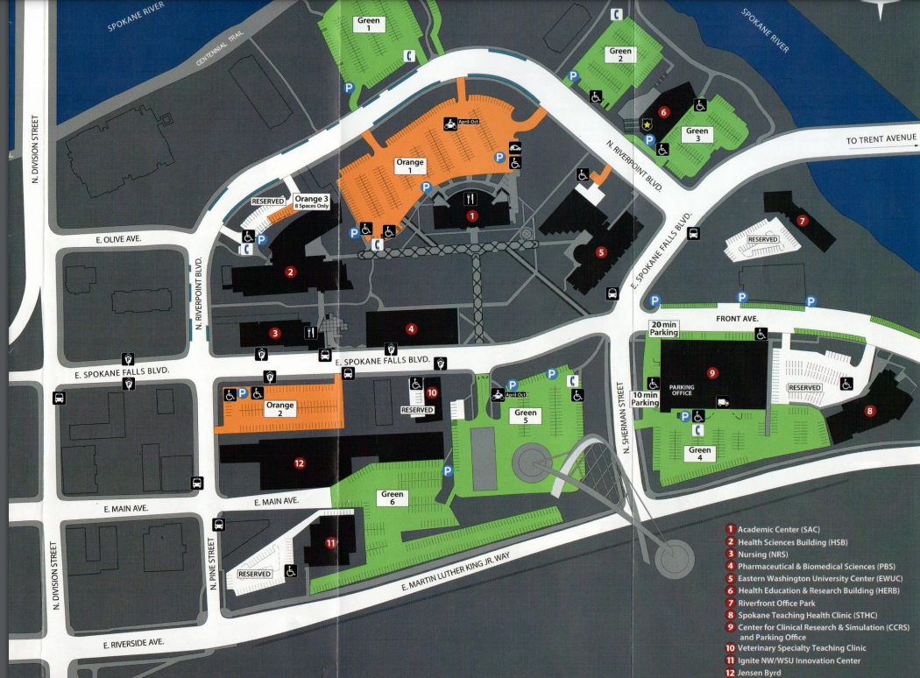
RECEPTION
CONFERENCE

