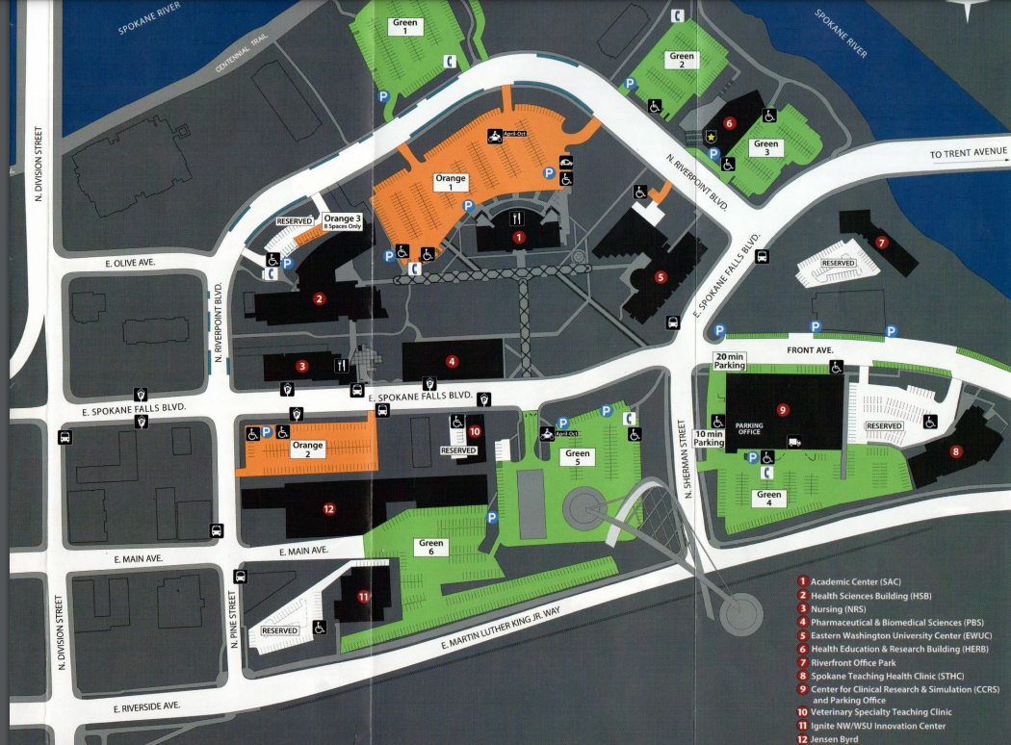
CONFERENCE
RECEPTION

